1. The virus detected in Section 1 is JS:Pdfka-FC, and the virus encountered in section 2 is JS:AGENT-AXQ.

JS:AGENT-AXQ is belong to one of the categories, Trojans. Trojan is one of the malware which performs activities without the user’s knowledge different from virus and worm. And JS/Agent is a large family of programs that secretly download, install and execute harmful files. If the computer is infected with JS:Agent-AXQ, you must have been infected with many other viruses. To find out if your computer is infected with spyware and adware, we must perform a full scan of the computer.

2.

1. Downloaded Maps Manager

If I don’t need to use the Bing Maps app, I can safely disable it.

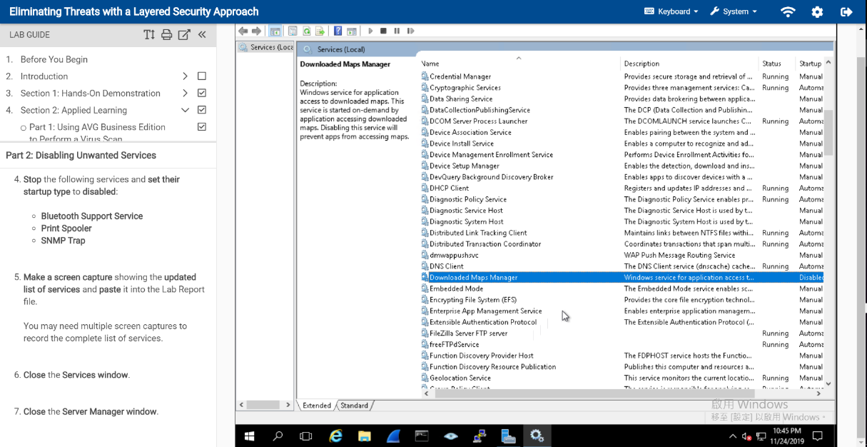

2. IP helper

If I don’t need to use IPv6 connection, I can stop and disable it.

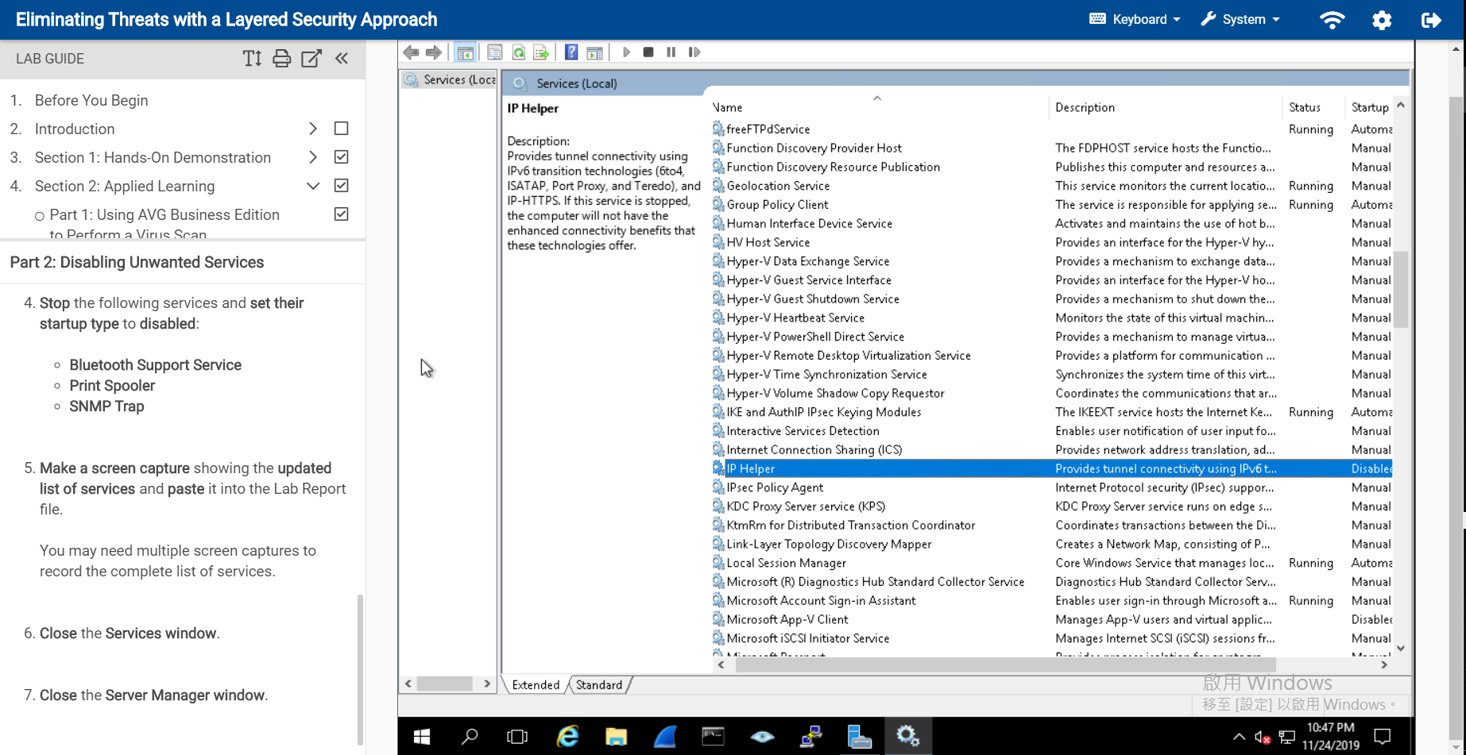

3. Internet Connection Sharing

Which is defined as an old service that can be disabled by Windows 10 official website.

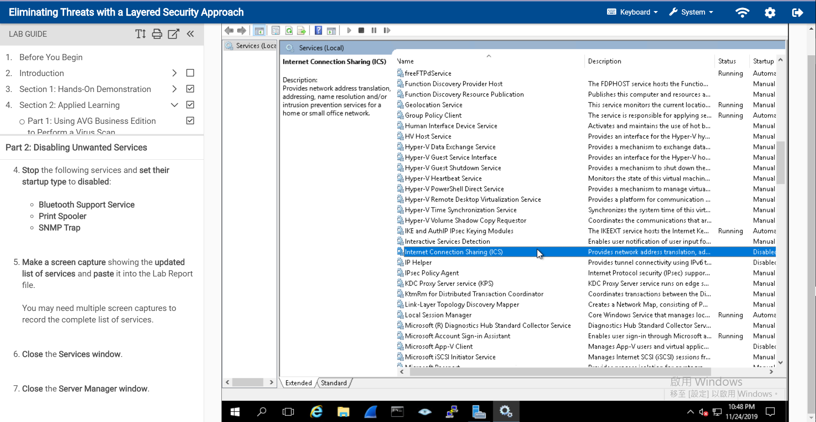

3.

This is the antivirus program Avira on my own computer. We have Real-time protection, Ransomware Protection, Web Protection, Mail Protection, and quick scan bar on the menu.

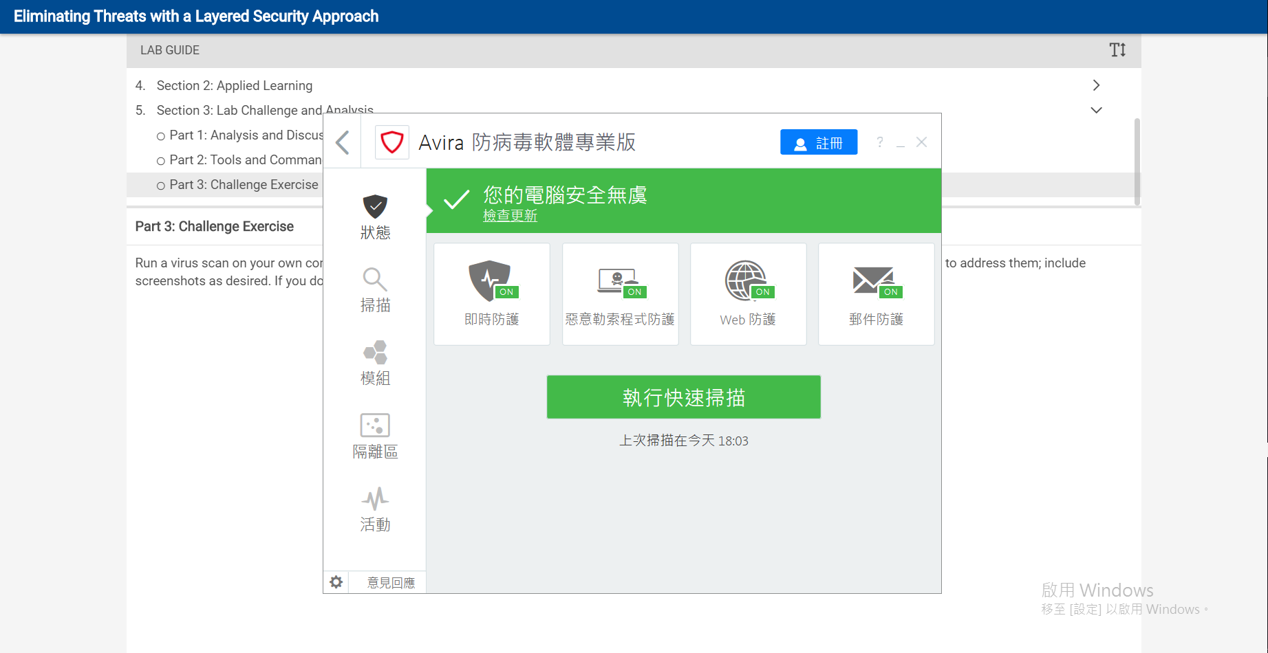

In the scan part, we have Full scan, Quick scan, Custom scan, Scheduler to choose how to scan the computer.

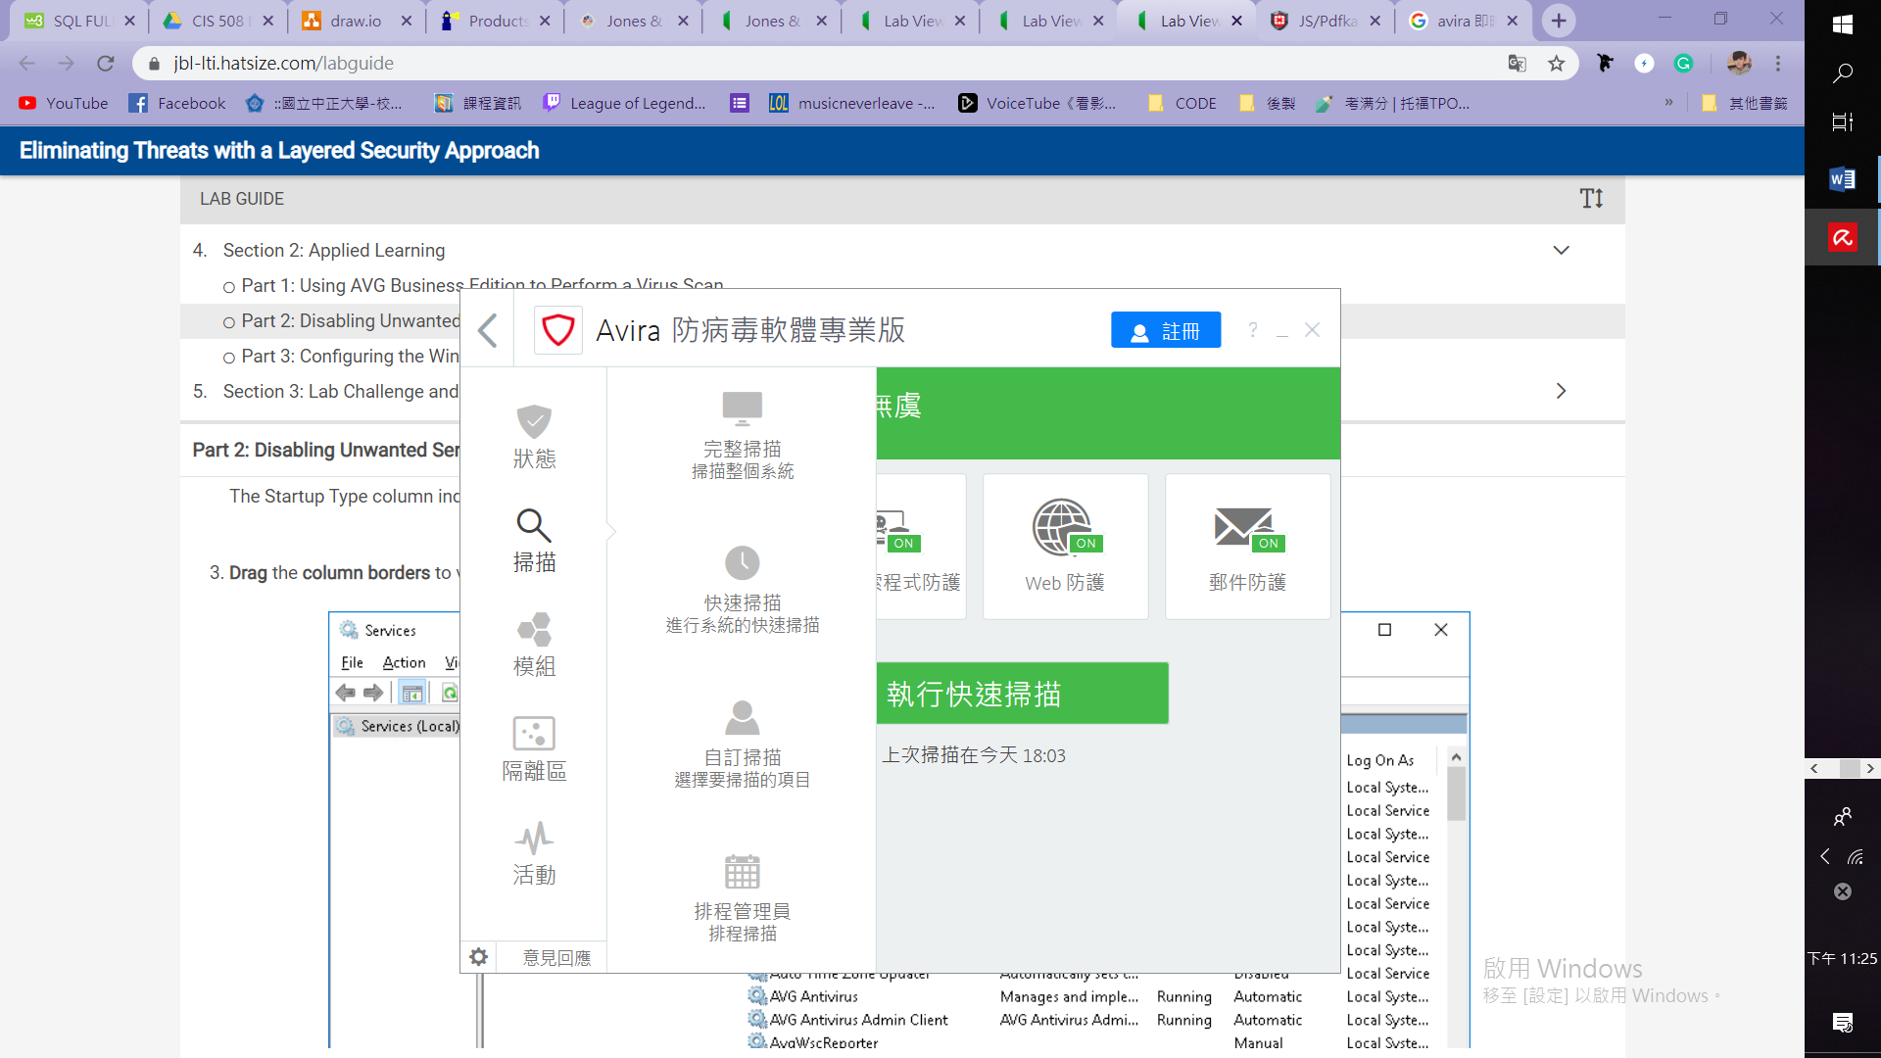

Choose Quick scan will auto scan the most vulnerable part of the computer, and save time.

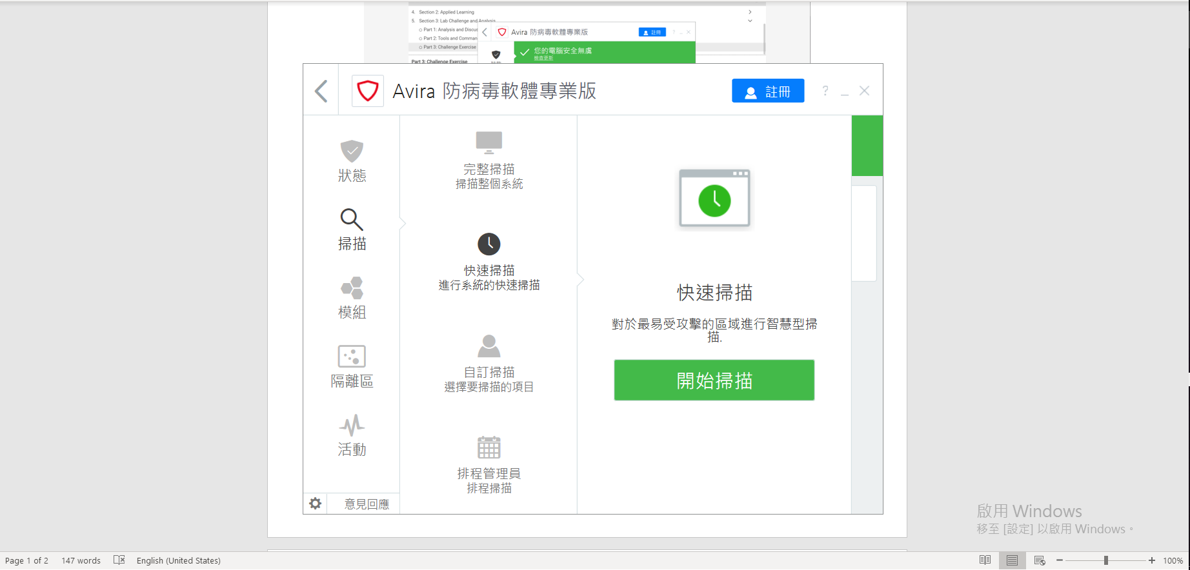

Scaning

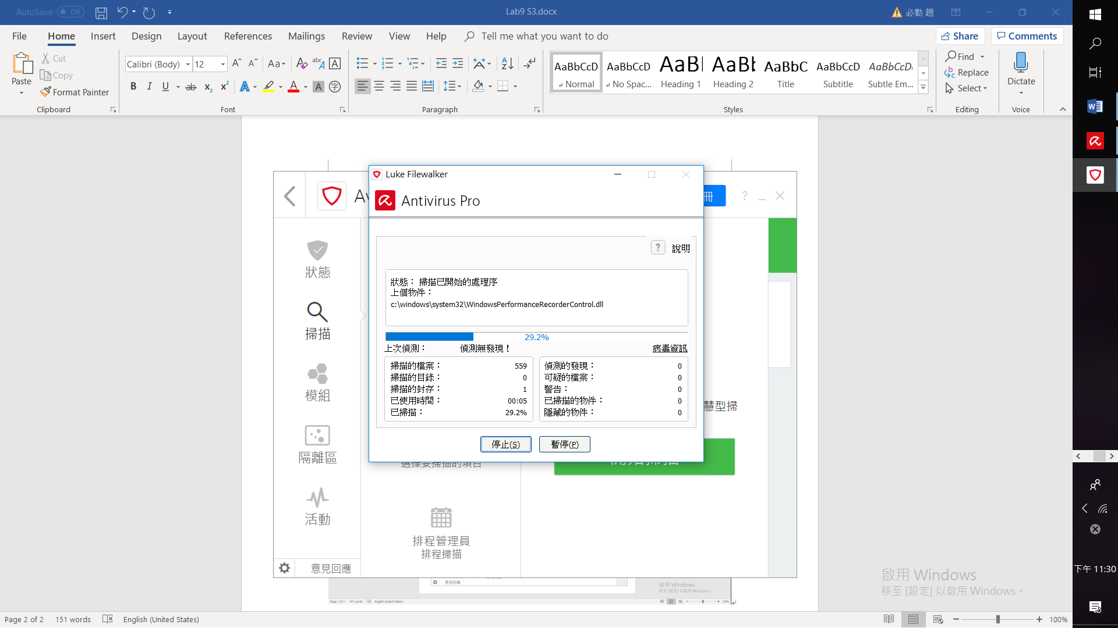

Successsful scanned.

